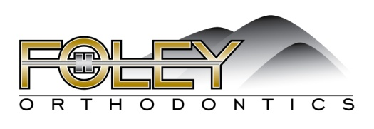
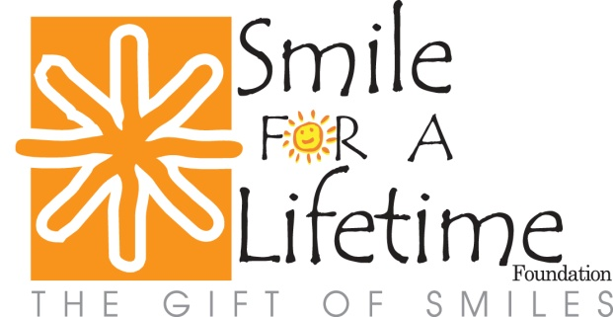

PRESS RELEASE
FOLEY ORTHODONTICS CREATES ORTHODONTIC FOUNDATION
(BECKLEY, WEST VIRGINIA) Residents of Raleigh, Summers, Fayette, Wyoming, Nicholas, Mercer, Webster and Braxton Counties now have another reason to smile.

Dr. Daniel Foley, of Foley Orthodontics, announced his newly formed foundation, Smile For A Lifetime. Dr. Foley created the local foundation to provide braces at no cost to individuals that cannot afford them in southern West Virginia.

“The mission of Smile For A Lifetime is to create self-confidence, inspire hope and change the lives of children in our community in a dramatic way” Foley explains. “The gift of a smile can produce a positive influence in an individual’s personal and professional life. When you feel good about yourself, it gives you the confidence to accomplish great things in your life and others.”

The foundation will award one set of braces per month to individuals that could not otherwise afford orthodontic treatment (approximately $60,000 donation to our community per year). If you, your child or a deserving individual you know could benefit from Smile For A Lifetime, please visit www.theperfectsmile.com to download application. Dr. Foley has recruited a local board of directors to help inform our community on the benefits of Smile For A Lifetime and to help determine the recipients.

The foundation does have income guidelines. Smile For A Lifetime provides free orthodontic services to qualified financially disadvantaged children as well as those with special circumstances. The West Virginia Medicaid Program provides orthodontic treatment for severe cases. Smile For A Lifetime is targeting children that have no orthodontic coverage, such as families on the WVCHIP Program (which has no orthodontic coverage).

Dr. Foley was born and raised in the Beckley area. He attended the College of West Virginia for two years and completed his bachelor’s degree in biology at West Virginia University. He also received his Doctor of Dental Surgery and Master’s degree in orthodontics from West Virginia University, where he graduated with honors

Dr. Foley has been creating beautiful smiles for over 15 years and has offices in Beckley, Summersville and Oceana. He is a board certified orthodontist and has attended several orthodontic courses all over the world to further his knowledge about the most innovative techniques in orthodontics. He shares his knowledge and experience in orthodontics to residents as a part time Clinical Professor at West Virginia University’s Orthodontic Residency Program.

He has been the president of the West Virginia Orthodontic Association and the West Virginia Orthodontic Alumni Association. He is also a member if the American Association of Orthodontics, American Dental Association, West Virginia Dental Association, and the New River Dental Society. Dr. Foley has a son named Luke, who would also like to be an orthodontist. You can learn more about Foley Orthodontics and the ways they create beautiful smiles at www.theperfectsmile.com.

